Call for Leadership Review at the
Irish Monument Park Foundation

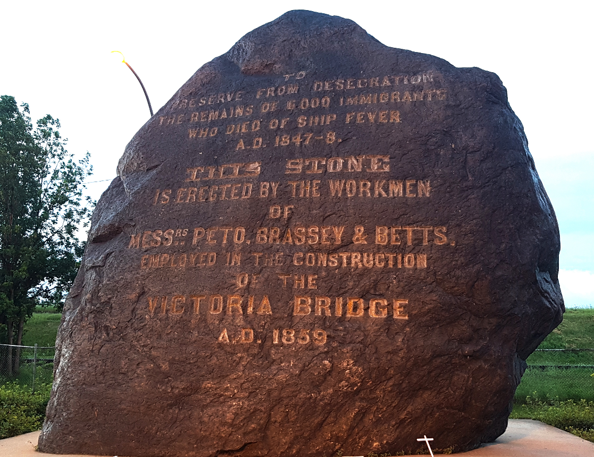

To: Hydro-Quebec

From: Donovan King, Historian and Director, Irish Monument Park Foundation

RE: Call for Leadership Review at the Irish Monument Park Foundation

August 23, 2022
Call for Leadership Review
at the Irish Monument Park Foundation

To - Stakeholders of the Project to Create a Memorial Park at the Site of the Black Rock, as originally proposed by the Irish Monument Park Foundation,
This is Donovan King writing, the historian at the Irish Monument Park Foundation and an original member of the Board of Directors. I wrote an academic paper about our Irish Famine Cemetery, which I understand that Hydro-Quebec found useful for navigating the issues involved.
I am writing today because I have some very serious concerns about a lack of proper Governance at the Irish Monument Park Foundation.

On behalf of the 6000+ Irish Famine Dead and others buried at the Black Rock Famine Cemetery, I would like to request a professional leadership review of the Irish Monument Park Foundation before Hydro-Quebec proceeds with the park project.

When I was asked to join the Board of Directors in 2014, I was under the impression that with a lot of hard work we might be able create a world-class park at the site of the Black Rock. After over a century of desecration against the memory of our ancestors, I decided to try to advance the project by writing and presenting academic papers and creating guided historical walking tours to the hallowed ground.

However, as time passed I began to realize that the project was not conforming to standard norms of Governance. As a member of my school’s Board of Governors and as a Union Rep for the Montreal Teachers Association, I am familiar with formal meetings, quorum, agendas, voting, minute-taking and other standard Governance procedures. At the Irish Monument Park Foundation there was no adherence to these norms. At first, I assumed that because the Foundation was so disorganized, it would likely take time to put these procedures in place.

However, I noticed that one of the Directors, Fergus V. Keyes, was using our platform to promote an offensive petition, which I considered racist against Indigenous people.
Being a Truth and Reconciliation activist, I take the Calls for Justice from The National Inquiry on Missing and Murdered Indigenous Women and Girls very seriously, including the following:
Calls for Justice for All Canadians
15.5 Confront and speak out against racism, sexism, ignorance, homophobia and transphobia, and teach or encourage others to do the same, wherever it occurs: in your home, in your workplace, or in social settings.
15.8 Help hold all governments accountable to act on the Calls for Justice, and to implement them according to the important principles we set out.
Sadly, Fergus subsequently blocked me from communicating on our social media pages. Furthermore, he then scrubbed my name from the Board of Directors on our website. I, along with Ronan Corbett of the GAA, were replaced with two Catholic members of the Saint Patrick Society:
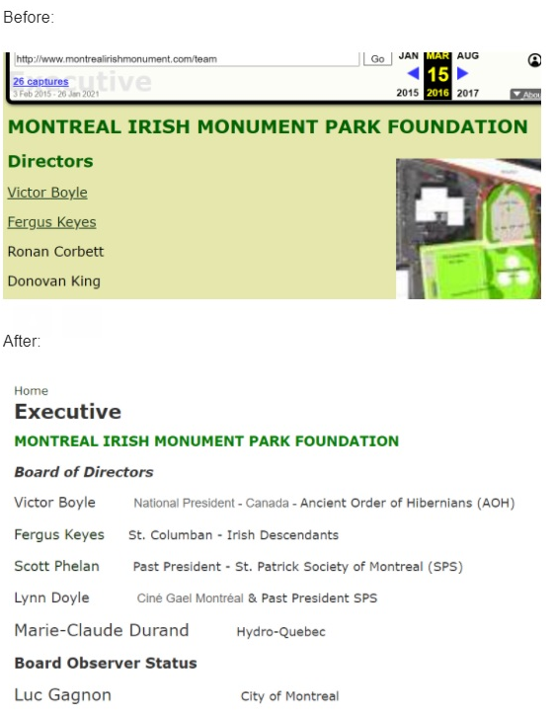
Again, this was done without any Governance. I was never voted off the Board of Directors nor did I resign. In fact, there were no meetings whatsoever and I only learned of the situation when a friend informed me that my name had been erased from the Irish Monument Park Foundation’s website.
What followed next was the Irish Monument Park Foundation announcing that it had agreed to permit the REM to drive a caisson (a large metal tube) through the remains of our ancestors. The rationale was to replace them from their final resting place with a concrete pylon to support the REM train line under construction.
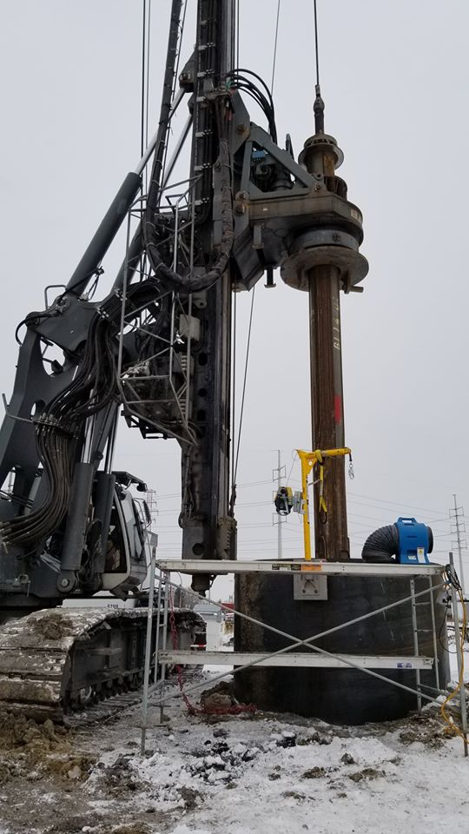
To my knowledge, this agreement between the REM and the Irish Monument Park Foundation was done with no Governance.

Had I been consulted at a Board of Directors meeting, I would have done everything in my power to find an alternative solution that did not desecrate our ancestors.

More recently, I discovered that Fergus V. Keyes had unilaterally made a beer deal with a microbrewery called 4 Origines to create a “Black Rock Beer”:

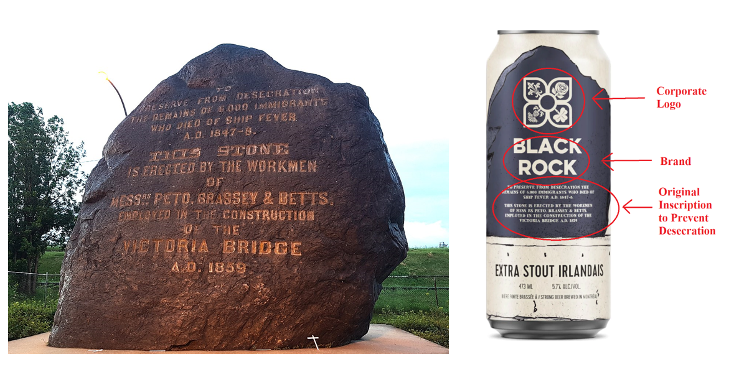
Given the sacred nature of our Famine burial ground, the “Black Rock Beer” sparked outrage in the local and international Irish community. There were many complaints from individuals at Concordia Irish Studies, The Irish Government and various other organizations - that the beer deal was yet another form of desecration against our Famine Dead. It was compared to a “Holocaust Wine” by some members of the Irish community.

Given that the Irish Monument Park Foundation was founded to protect our ancestors via the creation of a Memorial Park, I am very disappointed that instead deals are being made to desecrate it - with no Governance whatsoever.
As such, I am requesting an immediate Leadership Review of the Irish Monument Park Foundation by a third party, preferably a professional, independent organization that specializes in Governance issues. I want to ensure that the Board of Directors includes the original members, if they are willing, and that proper structures of Governance are put into place and adhered to.
The Irish community does not want any more of these damaging “deals” without our consent or support – we demand proper consultation and Governance.
Lastly, it is likely there are also Indigenous, French, Black and other people buried at the Black Rock site. In the summer of 1847, anyone who died of Typhus was sent to the Famine burial ground unless alternative arrangements were made. Over 1000 non-Famine victims died in Montreal in 1847 and Archdeacon Kerr said: "men of more than one denomination were buried there.”
Our Board of Directors should be diverse to reflect a broader range of the community. I personally think this should include a Mohawk member, especially as the Black Rock Famine Cemetery sits on un-ceded Mohawk territory.
I thank you for your consideration on these important matters and hope to hear back from you within 14 days, ideally with an Action Plan to rectify this disturbing situation.

Sincerely,

Donovan King, Historian and Original Director
Irish Monument Park Foundation

Bibliography
Kerr, Archdeacon. quote. Montreal: Montreal Gazette, March 2, 1910. https://www.newspapers.com/newspage/419370997/
Keyes, Fergus V. Counter-petition: Save the Statue of Sir John A. Macdonald in Montreal. Montreal: City Council of the City of Montreal: change.org, 2020. https://www.change.org/p/the-city-council-of-the-city-of-montreal-counter-petition-save-the-statue-of-sir-john-a-macdonald-in-montreal
King, Donovan. Montreal’s Irish Famine Cemetery: Commemoration Struggles from 1847 to the Present. Montreal: Concordia University, January, 2016. https://www.montrealirishmonument.com/sites/default/files/MontrealsIrishFamineCemetery.pdf
King, Donovan. Virtual Irish Famine in Montreal Walking Tour. Montreal: Bloomsday Montreal, 2020. https://www.youtube.com/watch?v=s6fwTKf9w_k
National Inquiry into Missing and Murdered Indigenous Women and Girls. Reclaiming Place: The Final Report. Quebec, June 3, 2019. www.mmiwg-ffada.ca/final-report/

Irish Famine Cemetery: Commemoration Struggles from 1847 to the Present: www.montrealirishmonument.com/sites/default/files/MontrealsIrishFamineCemetery.pdf
Virtual Irish Famine in Montreal Walking Tour: www.youtube.com/watch?v=s6fwTKf9w_k
Counter Petition: Save the Statue of Sir John A. Macdonald in Montreal: www.change.org/p/the-city-council-of-the-city-of-montreal-counter-petition-save-the-statue-of-sir-john-a-macdonald-in-montreal
Reclaiming Power and Place: The Final Report of the National Inquiry into Missing and Murdered Indigenous Women and Girls: www.mmiwg-ffada.ca/final-report/
Quote of Archdeacon Kerr: Montreal Gazette, 2 March 1910: https://www.newspapers.com/newspage/419370997/

